**About Project**

**1.1 Introduction**

The titeled **“Blood Donation Camp”** (BDC) is great project. this project is designed for successful completion of project on Blood Donation Camp. The basic building aim is to provide blood donation service to the city recently. Blood Donation Camp is a browser based system that is designed to store, process, retrieve and analyze information concerned with the administrative and inventory management within a blood bank. This project aims at maintaining all the information pertaining to blood donors, different blood groups available in each blood bank and help them manage in a better way. Aim is to provide transparency in this field, make the process of obtaining blood from a blood bank hassle free and corruption free and make the system of blood bank management effective.

The Blood Donation Camp project report contain information related to blood like

* Blood Type
* Date of Donation of Blood
* Validity of Bloods
* Available Blood Group

**1.2 Need of Blood Donation Camp**

Bank blood donation system in PHP is planned to collect blood from many donators in short from various sources and distribute that blood to needy people who require blood. To do all this we require high quality software to manage those jobs. The government spending lot of money to develop high quality “Blood Donation Camp” project. For do all those kinds of need Blood Donation Camp project in PHP contain modules which are include the detail of following areas:

1. Blood Donor
2. Equipments
3. Blood Recipient
4. Blood Collection
5. Camp
6. Stock Details
7. Blood Issued

**1.3 Abstract of Blood Donation Camp**

Help Line is an voluntary and non-governmental organization. It maintains Online library of blood donors in India. Sometimes Doctors and Blood bank project have to face the difficulty in finding the blood group Donors at right time. Help Line has attempted to provide the answer by taking upon itself the task of collecting Blood bank project nationwide for the cause and care of people in need.

At any point of time the people who are in need can reach the donors through our search facility. By mobilizing people and organization who desire to make a difference in the lives of people in need. On the basis of humanity, Everyone is welcome to register as a blood donor.

Blood Donation Camp is a browser based system that is designed to store, process, retrieve and analyze information concerned with the administrative and inventory management within a blood bank. This project aims at maintaining all the information pertaining to blood donors, different blood groups available in each blood bank and help them manage in a better way. Aim is to provide transparency in this field, make the process of obtaining blood from a blood bank hassle free and corruption free and make the system of blood bank management effective.

**1.4 Benefits**

**Our Vision**

In the IT era, there are almost not any fields exist where computers are not used. BDC would like to contribute to the total satisfaction to its esteemed customers by providing them with the high quality blood. BDC wants to make products highly reliable, affordable, & consistent which will serve the customer domain.

.

**Our Mission**

To endow with strategic and technical expertise to companies wanting to leverage the latest innovations.Our mission is to Define Quality Policy for the IT era, set new span for Services to customers.

**1.5 Features**

**1.5.1 Blood Donation Camp and Reporting**

1. Provides recording of details of camp beginning from allocation of staff, details of facilities available in the camp venue.
2. Provides assigning of donor to a particular camp and generate camp organizer report
3. Automated report generation of camp details for submission to the Government

**Donor Management**

1. The system allows automatic component data generation based on the component selected in the blood donor form.
2. The system allows bulk update for serology for blood units. Serology result for many donors can be updated at once.
3. The system allows for either component creation before serology test or vice versa. Based on the serology test, the component created are updated automatically
4. The system allows bar-coded blood bag number entry
5. All donor related reports are excel downloadable
6. All Reports provides filtering over many factors like Blood Group, gender, area, blood Camp, date of donation, donor type etc.
7. The system provides easy link for easy edit or adding details for various sections of the donor form
8. During form filling, the system notifies the user how much percentage of donor data has been updated

**1.5.2 Donor Test Results Management and Adverse Reaction Data Management**

1. Provides filterable selections for donor selections
2. Excel download of all reports
3. The reports are highly configurable and can be configured to display data as per institution requirements.
4. Search based on Component ID, Donor Registration ID, Donor BloodBag Number and Donor Name

**The results displayed in search is highly configurable**

The search functionality also allows for site-wide search. It means a user can search for any data available in the system

Custom links can be added in the search results to allow easier navigation and accessibility

**Blood Components Management**

1. Automatic generation of components form donor form
2. Based on the date of collection, the system automatically derives the date of expiry and disallows issue of component if unit has expired
3. Until the serology test is done, the system marks the status of the the component as test awaited. And only after serology test is done, the component is marked for Ready for Issue
4. The Available components list is available and the system automatically generates the list of components that are ready for issue to be available.

**Patient Management System**

1. Captures patient personal information as well as the hospital where blood is requireda)
2. The system allows for reserving a unit for 24 hours for a patient)
3. The blood component issued, the payment made as well as link to the final bill is available when the patient page is opened
4. The data allows reports like: Issue Register, Reserved Units and Patient Inventory Liste)
5. The system allows for capturing transfusion reaction data

**Blood Issue and Billing**

1. Ability to provide adjustments in the final payment receipt for concession for blood unit
2. The system prevents blood issue if cross-match is not done or fails
3. Final bill gets generated only if only the payment has been accounted for
4. Final bill gets generated only component selected has been serology tested and is ready for issue
5. Auto-generated final receipt
6. Auto-generated Cross-matching report
7. Managing Practical Solutions For Blood Bank Management
8. The system allows components to be created before serology and vice-versa.
9. The system takes care to automatically update the components when serology is done.

**1.6 Applications**

This application is built such a way that it should suits for all type of blood banks in future. So every effort is taken to implement this project in this blood bank, on successful implementation in this blood bank, we can target other blood banks in the city.

**1.7 Objective**

The main objective of this application is to automate the complete operations of the blood bank. They need maintain hundreds of thousands of records. Also searching should be very faster so they can find required details instantly.

To develop a web-based portal to facilitate the co-ordination between supply and demand of blood . This system makes conveniently available good quality, safe blood and other blood components, which can be provided in a sound, ethical and acceptable manner, consistent with the long-term well being of the community. It actively encourage voluntary blood donation, motivate and maintain a well-indexed record of blood donors and educate the community on the benefits of blood donation. This will also serve as the site for interaction of best practices in reducing unnecessary utilization of blood and help the state work more efficiently towards self-sufficiency in blood.

The system will provide the user the option to look at the details of the existing Donor List, Blood Group and to add a new Donor. It also allows the user to modify the record. The administrator can alter all the system data.

**2. About Front End**

The front end is an [interface](https://en.wikipedia.org/wiki/Interface_(computer_science)) between the user and the back end. The front and back ends may be distributed amongst one or more systems.

In [network computing](https://en.wikipedia.org/wiki/Computer_network), *front end* can refer to any hardware that optimizes or protects network traffic. It is called [application front-end hardware](https://en.wikipedia.org/wiki/Denial_of_service) because it is placed on the network's outward-facing front end or boundary. Network traffic passes through the front-end hardware before entering the network.

In [compilers](https://en.wikipedia.org/wiki/Compilers), the [front end](https://en.wikipedia.org/wiki/Compilers) translates a computer programming [source code](https://en.wikipedia.org/wiki/Source_code) into an [intermediate representation](https://en.wikipedia.org/wiki/Intermediate_representation), and the back end works with the intermediate representation to produce code in a computer output language. The back end usually optimizes to produce code that runs faster. The front-end/back-end distinction can separate the [parser](https://en.wikipedia.org/wiki/Parsing) section that deals with source code and the back end that [generates code and optimizes](https://en.wikipedia.org/wiki/Code_generation_(compiler)).

These days, front-end development refers to the part of the web users interact with. In the past, web development consisted of people who worked with Photoshop and those who could code HTML and CSS. Now, developers need a handle of programs like Photoshop and be able to code not only in HTML and CSS, but also JavaScript or jQuery, which is a compiled library of JavaScript.

Most of everything you see on any website is a mixture of HTML, CSS, and JavaScript, which are all controlled by the browser. For example, if you’re using Google Chrome or Firefox, the browser is what translates all of the code in a manner for you to see and with which to interact, such as fonts, colors, drop-down menus, sliders, forms, etc. In order for all of this to work, though, there has to be something to support the front-end; this is where the backend comes into play.

**2.1 Architecture of Front End User**

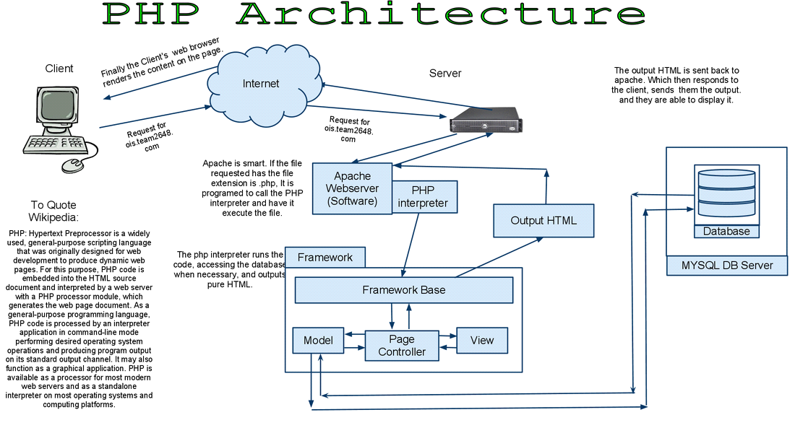

**2.1.1 Architecture and Concepts**

The query cache plugin is implemented as a PHP extension. It is written in C and operates under the hood of PHP. During the startup of the PHP interpreter, it gets registered as a [mysqlnd](http://php.net/manual/en/book.mysqlnd.php) plugin to replace selected mysqlnd C methods. Hereby, it can change the behaviour of any PHP MySQL extension ([mysqli](http://php.net/manual/en/ref.mysqli.php), [PDO_MYSQL](http://php.net/manual/en/ref.pdo-mysql.php), [mysql](http://php.net/manual/en/ref.mysql.php)) compiled to use the mysqlnd library without changing the extensions API. This makes the plugin compatible with each and every PHP MySQL application. Because existing APIs are not changed, it is almost transparent to use. Please, see the [mysqlnd plugin API description](http://php.net/manual/en/mysqlnd.plugin.php) for a discussion of the advantages of the plugin architecture and a comparison with proxy based solutions.

**2.1.2 Transparent to use**

At PHP run time PECL/mysqlnd_qc can proxy queries send from PHP ([mysqlnd](http://php.net/manual/en/book.mysqlnd.php)) to the MySQL server. It then inspects the statement string to find whether it shall cache its results. If so, result set is cached using a storage handler and further executions of the statement are served from the cache for a user-defined period. The Time to Live (TTL) of the cache entry can either be set globally or on a per statement basis.

A statement is either cached if the plugin is instructed to cache all statements globally using a or, if the query string starts with the SQL hint (*/*qc=on*/*). The plugin is capable of caching any query issued by calling appropriate API calls of any of the existing PHP MySQL extensions.

**2.1.3 Flexible Storage**

Various storage handler are supported to offer different scopes for cache entries. Different scopes allow for different degrees in sharing cache entries among clients.

* *default* (built-in): process memory, scope: process, one or more web requests depending on PHP deployment model used
* *APC*: shared memory, scope: single server, multiple web requests
* *SQLite*: memory or file, scope: single server, multiple web requests
* *MEMCACHE*: main memory, scope: single or multiple server, multiple web requests
* *user* (built-in): user-defined - any, scope: user-defined - any

Support for the *APC*, *SQLite* and *MEMCACHE* storage handler has to be enabled at compile time. The *default* and *user* handler are built-in. It is possible to switch between compiled-in storage handlers on a per query basis at run time. However, it is recommended to pick one storage handler and use it for all cache entries.

**2.1.4 Built-in slam defense to avoid overloading**

To avoid overload situations the cache plugin has a built-in slam defense mechanism. If a popular cache entries expires many clients using the cache entries will try to refresh the cache entry. For the duration of the refresh many clients may access the database server concurrently. In the worst case, the database server becomes overloaded and it takes more and more time to refresh the cache entry, which in turn lets more and more clients try to refresh the cache entry. To prevent this from happening the plugin has a slam defense mechanism. If slam defense is enabled and the plugin detects an expired cache entry it extends the life time of the cache entry before it refreshes the cache entry. This way other concurrent accesses to the expired cache entry are still served from the cache for a certain time.The other concurrent accesses to not trigger a concurrent refresh. Ideally, the cache entry gets refreshed by the client which extended the cache entries lifespan before other clients try to refresh the cache and potentially cause an overload situation.

**2.1.5 Unique Approach to Caching**

PECL/mysqlnd_qc has a unique approach to caching result sets that is superior to application based cache solutions. Application based solutions first fetch a result set into PHP variables. Then, the PHP variables are serialized for storage in a persistent cache, and then unserialized when fetching. The mysqlnd query cache stores the raw wire protocol data sent from MySQL to PHP in its cache and replays it, if still valid, on a cache hit. This way, it saves an extra serialization step for a cache put that all application based solutions have to do. It can store the raw wire protocol data in the cache without having to serialize into a PHP variable first and deserializing the PHP variable for storing in the cache a

**3.2 Software and Tools Used**

**1. PHP**

**3.2.1 Introduction**

PHP is now officially known as “**PHP: Hypertext Preprocessor**”. It is a server-side scripting language usually written in an HTML context. Unlike an ordinary HTML page, a PHP script is not sent directly to a client by the server; instead, it is parsed by the PHP binary or module, which is server-side installed. HTML elements in the script are left alone, but PHP code is interpreted and executed. PHP code in a script can query databases, create images, read and write files, talk to remote servers – the possibilities is endless. The output from PHP code is combined with the HTML in the script and the result sent to the user’s web-browser, therefore it can never tell the user whether the web-server uses PHP or not, because the entire browser sees is HTML.

PHP’s support for Apache and MySQL further increases its popularity. Apache is now the most-used web-server in the world, and PHP can be compiled as an Apache module. MySQL is a powerful free SQL database, and PHP provides a comprehensive set of functions for working with it. The combination of Apache, MySQL and PHP is all but unbeatable.

That doesn’t mean that PHP cannot work in other environments or with other tools. In fact, PHP supports an extensive list of databases and web-servers. While in the mid-1990s it was ok to build sites, even relatively large sites, with hundreds of individual hard-coded HTML pages, today’s webmasters are making the most of the power of databases to manage their content more effectively and to personalize their sites according to individual user preferences.

**Reasons for using PHP**

There are some indisputable great reasons to work with PHP. As an open source product, PHP is well supported by a talented production team and a committed user community. Furthermore, PHP can be run on all the major operating systems with most servers.

**a)** **Learning PHP is easy**Basic is easy any interpreted language should be easy to learn. Since you are isolated from the system (no pointers to use, no memory to allocate). The other advantage that all modern interpreted languages share is good associative array constructs.

**b)** **Its Performance**

While we can build an application that serves millions of pages a day on a server, when we really look at the performance of the language it sucks. We are still orders of magnitude from real performance. Not only that, but since PHP is designed around a single process model our ability to share data structures or connection pool resources is left to native code libraries.

**c) The low cost**

There are many languages which are available at very less cost. There are some languages which are available at very less cost like below:

1. PHP
2. C
3. C++ etc

**d) It’s Open Source, We can modify it**

We can modify it if you need a hole in your head! Technically the point is that it’s an open source project and they release patches often. You’re point is that the community is actively working out the bugs. So, what any active language is doing this...

Unfortunately C, C++ and Perl have all “died” at this point and will pretty much remain static at their current functionality.

* Its Portability
* It has interfaces to a large variety of database systems
* PHP supports a large variety of the database.
* Support available
* Online Support is available for using PHP.

**e)PHP Syntax**

You cannot view the PHP source code by selecting “View source” in the browser – you will only see the output from the PHP file, which is plain HTML. This is because the scripts are executed on the server before the result is sent back to the browser.

**Basic PHP Syntax**

A PHP scripting block always starts with **<?php** and ends with **?>**. A PHP scripting block can be placed anywhere in the document. On servers with shorthand support enabled you can start a scripting block with <? And end with ?>. However, for maximum compatibility, we recommend that you use the standard form (<?php) rather than the shorthand form.

A PHP file normally contains HTML tags, just like an HTML file, and some PHP scripting code.

**3.2.2 HTML**

**HTML** or **Hyper Text Markup Language** is the standard markup language used to create web pages.

HTML was created in 1991 by Tim Berners-Lee at CERN in Switzerland. It was designed to allow scientists to display and share their research.

HTML is written in the form of HTML elements consisting of *tags* enclosed in angle brackets(like <html>). HTML tags most commonly come in pairs like <h1> and </h1>, although some tags represent *empty elements* and so are unpaired, for example <img>. The first tag in a pair is the *start tag*, and the second tag is the *end tag* (they are also called *opening tags* and *closing tags*).

The purpose of a web browser is to read HTML documents and compose them into visible or audible web pages. The browser does not display the HTML tags, but uses the tags to interpret the content of the page. HTML describes the structure of a website semantically along with cues for presentation, making it a markup language rather than a programming language.

HTML elements form the building blocks of all websites. HTML allows images and objects to be embedded and can be used to create interactive forms. It provides a means to create structured documents by denoting structural semantics for text such as headings, paragraphs, lists, links, quotes and other items. It can embed scripts written in languages such as Java Script which affect the behavior of HTML web pages.

HTML is descriptive markup language. Library of various markup languages is defined in various browsers.

**a) HTML Images - The <img> Tag and the Src Attribute**

In HTML, images are defined with the <img> tag.

The <img> tag is empty, which means that it contains attributes only, and has no closing tag.

To display an image on a page, you need to use the src attribute. Src stands for "source". The value of the src attribute is the URL of the image you want to display.

**Syntax for defining an image:**

<imgsrc="*url*" alt="*some_text*">

**b) HTML Forms**

HTML forms are used to pass data to a server.

An HTML form can contain input elements like text fields, checkboxes, radio-buttons, submit buttons and more. A form can also contain select lists, textarea, fieldset, legend, and label elements.

**c)** **Image tag (<img>) :**

To add an image to an HTML document, we just need to include an <IMG> tag with a

reference to the desired image. The <IMG> tag is an empty element i.e. it doesn’t require a

closing tag and we can use it to include from small icons to large images.

**Syntax: <imgsrc=”URL” alt=”alternative text”>**

**d) HTML Lists :**

|  |  |
| --- | --- |
| An ordered list:   * The first list item * The second list item * The third list item | An unordered list:   * List item * List item * List item |

**3.2.3 HTML 5**

HTML5 will be the new standard for HTML. The previous version of HTML, HTML 4.01,

came in 1999. The web has changed a lot since then. HTML5 is still a work in progress.

However, the major browsers support many of the new HTML5 elements and APIs.

HTML5 is cooperation between the World Wide Web Consortium (W3C) and the Web

Hypertext Application Technology Working Group (WHATWG).

WHATWG was working with web forms and applications, and W3C was working with

XHTML 2.0. In 2006, they decided to cooperate and create a new version of HTML.

Some rules for HTML5 were established:

a) New features should be based on HTML, CSS, DOM, and JavaScript

b) Reduce the need for external plug-ins (like Flash)

c) Better error handling

d) More markup to replace scripting

e) HTML5 should be device independent

f) The development process should be visible to the public

**3.2.4 CSS**

**CSS tutorial** or CSS 3 tutorial provides basic and advanced concepts of CSS technology. Our CSS tutorial is developed for beginners and professionals. The major points of CSS are given below:

* CSS stands for Cascading Style Sheet.
* CSS is used to design HTML tags.
* CSS is a widely used language on the web.
* HTML, CSS and JavaScript are used for web designing. It helps the web designers to apply style on HTML tags.

**Cascading Style Sheets** (**CSS**) is a style sheet language used for describing the look and formatting of a document written in a markup language. While most often used to style web pages and user interfaces written in HTML and XHTML, the language can be applied to any kind of XML document, including plain XML, SVG and XUL. CSS is a cornerstone specification of the web and almost all web pages use CSS style sheets to describe their presentation.

CSS is designed primarily to enable the separation of document content from document presentation, including elements such as the layout, colors, and fonts. This separation can improve content accessibility, provide more flexibility and control in the specification of presentation characteristics, enable multiple pages to share formatting, and reduce complexity and repetition in the structural content (such as by allowing for table less web design).

CSS can also allow the same markup page to be presented in different styles for different rendering methods, such as on-screen, in print, by voice (when read out by a speech-based browser or screen reader) and on Braille-based, tactile devices. It can also be used to allow the web page to display differently depending on the screen size or device on which it is being viewed. While the author of a document typically links that document to a CSS file, readers can use a different style sheet, perhaps one on their own computer, to override the one the author has specified.

With plain HTML you define the colors and sizes of text and tables throughout your pages. If

you want to change a certain element you will therefore have to work your way through the

document and change it. With CSS you define the colors and sizes in "styles". Then as you

write your documents you refer to the styles. Therefore: if you change a certain style it will

change the look of your entire site. Another big advantage is that CSS offers much more

detailed attributes than plain HTML for defining the look and feel of your site.

**3.2.5 Javascript**

**JavaScript** (**JS**) is a dynamic computer programming language. It is most commonly used as part of web browsers, whose implementations allow client-side scripts to interact with the user, control the browser, communicate asynchronously, and alter the document content that is displayed. It is also being used in server-side network programming (with Node.js), game development and the creation of desktop and mobile applications.

JavaScript is a prototype-based scripting language with dynamic typing and has first-class functions. Its syntax was influenced by C. JavaScript copies many names and naming conventions from Java, but the two languages are otherwise unrelated and have very different semantics. The key design principles within JavaScript are taken from the Self and Scheme programming languages. It is a multi-paradigm language, supporting object-oriented, imperative, and functional programming styles.

The application of JavaScript in use outside of web pages—for example, in PDF documents, site-specific browsers, and desktop widgets—is also significant. Newer and faster JavaScript VMs and platforms built upon them (notably Node.js) have also increased the popularity of JavaScript for server-side web applications. On the client side, JavaScript was traditionally implemented as an interpreted language but just-in-time compilation is now performed by recent (post-2012) browsers.

JavaScript was formalized in the ECMA Script language standard and is primarily used as part of a web browser (client-side JavaScript). This enables programmatic access to objects within a host environment.

JavaScript is the most popular programming language in the world.

It is the language for HTML, for the Web, for computers, servers, laptops, tablets, smart phones, and more.

You can use JavaScript to:

a) Change HTML elements

* Delete HTML elements
* Create new HTML elements
* Copy and clone HTML elements

**4. About Back End**

In a previous blog, we talked about how web programmers are concerned with launching websites, updates, and maintenance, among other things. All of that works to support the front-end of the website. The back-end has three parts to it: server, application, and database.

To better explain how all of this works, let’s use the example of a customer trying to purchase a plane ticket using a website. Everything that the customer sees on the webpage is the front-end, as we have explained before, but once that customer enters all of his or her information, ssssuch as their name, billing address, destination, etc, the web application stores the information in a database that was created previously on the server in which the website is calling for information.

The web application creates, deletes, changes, renames, etc items in the database. For example, when a customer purchases a ticket, that creates an item in the database, but when they have a change in their order or they wish to cancel, the item in the database is changed.

.In short, when a customer wants to buy a ticket, the backend operation is the web application communicating with the server to make a change in a database stored on said server. Technologies like PHP, Ruby, Python, and others are the ones backend programmers use to make this communication work smoothly, allowing the customer to purchase his or her ticket with ease.

**4.1 MySQL’s Logical Architecture**

The topmost layer contains the services that aren’t unique to MySQL. They’re services most network-based client/server tools or servers need: connection handling, authentication, security, and so forth.

.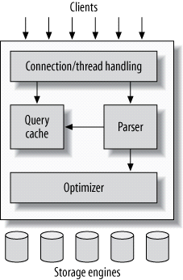

The third layer contains the storage engines. They are responsible for storing and retrieving all data stored “in” MySQL. Like the various filesystems available for GNU/Linux, each storage engine has its own benefits and drawbacks. The server communicates with them through the *storage engine API*. This interface hides differences between storage engines and makes them largely transparent at the query layer. The API contains a couple of dozen low-level functions that perform operations such as “begin a transaction” or “fetch the row that has this primary key.” The storage engines don’t parse SQL[[4](https://www.safaribooksonline.com/library/view/high-performance-mysql/9781449332471/ch01.html)] or communicate with each other; they simply respond to requests from the server.

|  |
| --- |
|  |

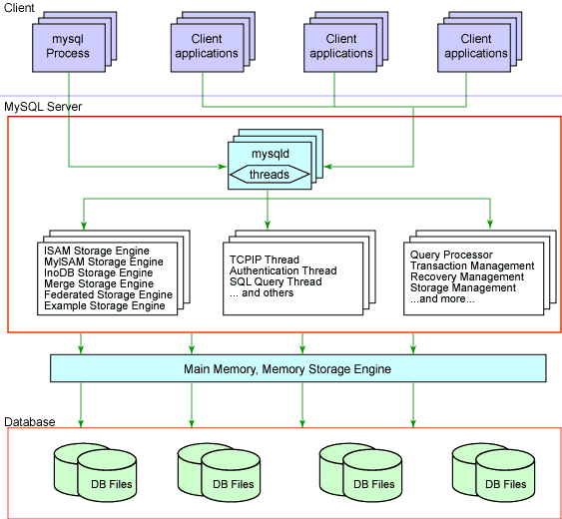

**4.2 Softwares and Tools Used**

**4.2.1 MySQL**

The database has become an integral part of almost every human's life. Without it, many things we do would become very tedious, perhaps impossible tasks. Banks, universities, and libraries are three examples of organizations that depend heavily on some sort of database system. On the Internet, search engines, online shopping, and even the website naming convention would be impossible without the use of a database. A database that is implemented and interfaced on a computer.

One of the fastest SQL (Structured Query Language) database servers currently on the market is the MySQL server, developed by T.c.X. DataKonsultAB. MySQL, available for download at [www.mysql.com](http://www.mysql.com/), offers the database programmer with an array of options and capabilities rarely seen in other database servers. MySQL is free of charge for those wishing to use it for private and commercial use. Those wishing to develop applications specifically using MySQL should consult MySQL's licensing section, as there is charge for licensing the product.

**These capabilities range across a number of topics, including the following:**

a) Ability to handle an unlimited number of simultaneous users.

b) Capacity to handle 50,000,000+ records.

c) Very fast command execution, perhaps the fastest to be found on the market.

d)Easy and efficient user privilege system.

However, perhaps the most interesting characteristic of all is the fact that it's free. That's right, T.c.X offers MySQL as a free product to the general public.

**Reasons to Use MySQL**

**a) Scalability and Flexibility**

The MySQL database server provides the ultimate in scalability, sporting the capacity to handle deeply embedded applications with a footprint of only 1MB to running massive data warehouses holding terabytes of information. Platform flexibility is a stalwart feature of MySQL with all flavors of Linux, UNIX, and Windows being supported.

**b) High Performance**

A unique storage-engine architecture allows database professionals to configure the MySQL database server specifically for particular applications, with the end result being amazing performance results.

**c) High Availability**

Rock-solid reliability and constant availability are hallmarks of MySQL, with customers relying on MySQL to guarantee around-the-clock uptime. MySQL offers a variety of high-availability options from high-speed master/slave replication configurations, to specialized Cluster servers offering instant failover, to third party vendors offering unique high-availability solutions for the MySQL database server.

**d) Robust Transactional Support**

MySQL offers one of the most powerful transactional database engines on the market. Features include complete ACID (atomic, consistent, isolated, durable) transaction support, unlimited row-level locking, distributed transaction capability, and multi-version transaction support where readers never block writers and vice-versa.

**e) Web and Data Warehouse Strengths**

MySQL is the de-facto standard for high-traffic web sites because of its high-performance query engine, tremendously fast data inserts capability, and strong support for specialized web functions like fast full text searches.

**f) Strong Data Protection**

Because guarding the data assets of corporations is the number one job of database professionals, MySQL offers exceptional security features that ensure absolute data protection. In terms of database authentication, MySQL provides powerful mechanisms for ensuring only authorized users have entry to the database server, with the ability to block users down to the client machine level being possible.

**g) Management Ease**

MySQL offers exceptional quick-start capability with the average time from software download to installation completion being less than fifteen minutes. This rule holds true whether the platform is Microsoft Windows, Linux, Macintosh, or UNIX.

**PHP Main Features of MySQL**

* Tested with a broad range of different compilers.
* Works on many different platforms.
* The MySQL Server design is multi-layered with independent modules.
* Fully multi-threaded using kernel threads. It can easily use multiple CPUs if they are available.
* Provides transactional and non-transactional storage engines.
* Uses very fast B-tree disk tables with index compression.
* Relatively easy to add other storage engines.
* This is useful if you want to provide an SQL interface for an in-house database.
* A very fast thread-based memory allocation system.
* Very fast joins using an optimized one-sweep multi-join.
* In-memory hash tables, which are used as temporary tables.
  + 1. **XAMPP**

XAMPP is an abbreviation for cross-platform, Apache, MySQL, PHP and Perl, and it allows you to build WordPress site offline, on a local web server on your computer. This simple and lightweight solution works on Windows, Linux, and Mac – hence the “cross-platform” part.

Since WordPress isn’t a stand-alone application, XAMPP provides two essential components for its installation – Apache, which is used to create the local server, and MySQL which you can use as a database for your website.

You may be wondering why and how developers are using WordPress local server. The answer is simple – it allows them to create a local copy of the site in which they can try out new plugin updates before implementing them on its live version.

Now it’s time to dive deeper into this XAMPP tutorial and learn how to locally host a website on Windows, Mac, or Linux.

**Running XAMPP**

If you accidentally unchecked the box, don’t worry. You can go to your XAMPP folder on your computer and manually run XAMPP Control Panel.

Note: Before using XAMPP, check that you don’t have conflicting applications that are using the same ports running in the background. Skype is a perfect example. Exit those applications are restart XAMPP.

If the installation didn’t run into any errors, the control panel would show black and blue text below the list of the panel’s components (Apache, MySQL etc.). All of the elements have their separate Start/Stop, Admin, Config, and Logs buttons.

Run Apache and MySQL by clicking their Start buttons. If the components started without problems, you would see a green background behind their names. Congratulations! You have successfully installed XAMPP server on your computer.

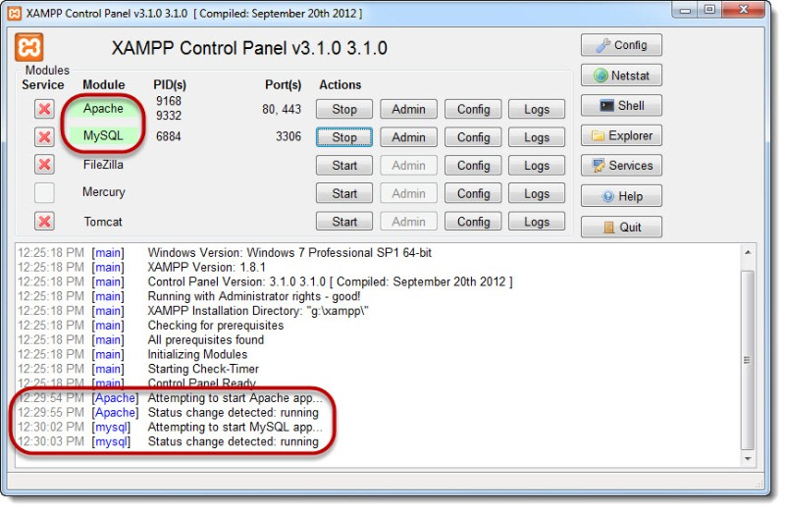

PHP server is a collection of tools that make hosting at local servers possible so you can build or develop Web Apps at your computer.

If you are going to develop a web application, having a PHP server is the best way to begin.

**Four Essential tools for PHP Servers are:**

* Operating System
* Web Server
* DBMS
* PHP

Let’s look at each one:

**Operating System**

Operating System is system software that manages computer hardware and various software.

The operating system helps you in communicating with the computer. Humans can’t use any computer that does not have any operating system.

Most popular computer operating systems are:

* Windows
* Linux
* Mac OS

**Web Server**

A Web server is a program that uses HTTP (Hypertext Transfer Protocol) to serve the files that form Web pages to users.

Popular Open Source Web Server are:

* Internet Information Service
* Apache HTTP Server
* LIGHTTPD
* NGINX
* Node.js

**DBMS**

MariaDB and MySQL are the most popular Database Management Systems.

A DBMS does processing and managing of data.

**PHP**

Last but not least is PHP.

PHP is a server scripting language, developed to make dynamic web pages. The PHP interpreter executes PHP language.

Why using PHP Server Stacks?

If you are a developer, you know how frustrating it is to install a Web Server.

It does not end at web servers, developers also have to install PHP, MariaDB, and sometimes Pearl, Ruby and other programming languages.

They are the basic requirements for creating localhost.

Here, these **PHP Servers stacks become helpful**.

They are a **one-click installer** of various useful programs that a developer needs to create an environment for web app deployment.

Best PHP Servers Stacks

There are many open-source PHP server packages available on the internet. The names of the packs are often acronym of the tools they contain.

Here are few Best PHP Servers:

* [XAMPP](https://serverguy.com/servers/php-servers/#xampp)
* [LAMP](https://serverguy.com/servers/php-servers/#lamp)
* [LEMP](https://serverguy.com/servers/php-servers/#lemp)
* [MAMP](https://serverguy.com/servers/php-servers/#mamp)
* [WAMP](https://serverguy.com/servers/php-servers/#wamp)
* [AMPSS](https://serverguy.com/servers/php-servers/#ampss)
* [EasyPHP](https://serverguy.com/servers/php-servers/#easyphp)

**XAMPP**

XAMPP is an open-source software developed and distributed by Apache Friends.

It is an acronym for:

* X- Cross-Platform
* A- Apache Server
* M- MariaDB
* P- PHP
* P- Pearl

XAMPP is one of the most common PHP servers packages used by developers for developing the sites.

It was the first platform of such capability. It makes the task of installation of PHP Servers a lot easier for developers. You don’t need any technical help to install XAMPP.

Developers used to install each tool separately, but XAMPP offered them all the tools in one-click installation. Hence, it made the task less time-consuming.

The user interface is simple and easy to learn. Other than PHP, it also offers Pearl.

**5. Minimum Hardware Specification**

**5.1 Hardware Requirement**

Processor : Intel Core Duo 2.0 GHz or more

RAM : 1 GB or More

Harddisk : 80GB or more

Monitor : 15” CRT, or LCD monitor

Keyboard : Normal or Multimedia

Mouse : Compatible mouse

**5.2 Software Requirement**

Front End : HTML/CSS/JS/JQUERY/PHP/BOOTSTRAP

Back End : MYSQL

Operation System : Windows 10

**6.4 CSS**

**CSS** provides basic and advanced concepts of CSS technology. The major points of CSS are given below:

* CSS stands for Cascading Style Sheet.
* CSS is used to design HTML tags.
* CSS is a widely used language on the web.
* HTML, CSS and JavaScript are used for web designing.
* It helps the web designers to apply style on HTML tags.

**Cascading Style Sheets** (**CSS**) is a style sheet language used for describing the look and formatting of a document written in a markup language. While most often used to style web pages and user interfaces written in HTML and XHTML, the language can be applied to any kind of XML document, including plain XML, SVG and XUL. CSS is a cornerstone specification of the web and almost all web pages use CSS style sheets to describe their presentation.

CSS is designed primarily to enable the separation of document content from document presentation, including elements such as the layout, colors, and fonts. This separation can improve content accessibility, provide more flexibility and control in the specification of presentation characteristics, enable multiple pages to share formatting, and reduce complexity and repetition in the structural content (such as by allowing for table less web design).

CSS can also allow the same markup page to be presented in different styles for different rendering methods, such as on-screen, in print, by voice (when read out by a speech-based browser or screen reader) and on Braille-based, tactile devices. It can also be used to allow the web page to display differently depending on the screen size or device on which it is being viewed. While the author of a document typically links that document to a CSS file, readers can use a different style sheet, perhaps one on their own computer, to override the one the author has specified.

With plain HTML you define the colors and sizes of text and tables throughout your pages. If

you want to change a certain element you will therefore have to work your way through the

document and change it. With CSS you define the colors and sizes in "styles". Then as you

write your documents you refer to the styles. Therefore: if you change a certain style it will

change the look of your entire site. Another big advantage is that CSS offers much more

detailed attributes than plain HTML for defining the look and feel of your site.

**6.5 Javascript**

**JavaScript** (**JS**) is a dynamic computer programming language. It is most commonly used as part of web browsers, whose implementations allow client-side scripts to interact with the user, control the browser, communicate asynchronously, and alter the document content that is displayed. It is also being used in server-side network programming (with Node.js), game development and the creation of desktop and mobile applications.

JavaScript is a prototype-based scripting language with dynamic typing and has first-class functions. Its syntax was influenced by C. JavaScript copies many names and naming conventions from Java, but the two languages are otherwise unrelated and have very different semantics. The key design principles within JavaScript are taken from the Self and Scheme programming languages. It is a multi-paradigm language, supporting object-oriented, imperative, and functional programming styles.

The application of JavaScript in use outside of web pages—for example, in PDF documents, site-specific browsers, and desktop widgets—is also significant. Newer and faster JavaScript VMs and platforms built upon them (notably Node.js) have also increased the popularity of JavaScript for server-side web applications. On the client side, JavaScript was traditionally implemented as an interpreted language but just-in-time compilation is now performed by recent (post-2012) browsers.

JavaScript was formalized in the ECMA Script language standard and is primarily used as part of a web browser (client-side JavaScript). This enables programmatic access to objects within a host environment. JavaScript is the most popular programming language in the world. It is the language for HTML, for the Web, for computers, servers, laptops, tablets, smart phones, and more.

You can use JavaScript to:

a) Change HTML elements

* Delete HTML elements
* Create new HTML elements
* Copy and clone HTML elements

**8. Software Development Process**

**8.1 Life Cycle Used to develop this Project**

Systems Development Life Cycle (SDLC), or *Software Development Life Cycle*, in systems engineering and software engineering relates to the process of developing systems, and the models and methodologies, that people use to develop these systems, generally computer or information systems. In software engineering this SDLC concept is developed into all kinds of software development methodologies, the framework that is used to structure, plan, and control the process.

**8.1 Overview**

Systems Development Life Cycle (SDLC) is any logical process used by a systems analyst to develop an information system, including requirements, validation, training, and user ownership. An SDLC should result in a high quality system that meets or exceeds customer expectations, within time and cost estimates, works effectively and efficiently in the current and planned Information Technology infrastructure, and is cheap to maintain and cost-effective to enhance.

Computer systems have become more complex and usually (especially with the advent of Service-Oriented Architecture) link multiple traditional systems often supplied by different software vendors. To manage this, a number of system development life cycle (SDLC) models have been created: waterfall, fountain, spiral, build and fix, rapid prototyping, incremental, and synchronize and stabilize. Although in the academic sense, SDLC can be used to refer to various models, SDLC is typically used to refer to a waterfall methodology.

In project management a project has both a life cycle and a "systems development life cycle" during which a number of typical activities occur. The project life cycle (PLC) encompasses all the activities of the project, while the systems development life cycle (SDLC) is focused on accomplishing the product requirements.

**7.2 Systems Development Phases**

Systems Development Life Cycle (SDLC) adheres to important phases that are essential for developers, such as planning, analysis, design, and implementation, and are explained in the section below. There are several Systems Development Life Cycle Models in existence. The oldest model, that was originally regarded as "the Systems Development Life Cycle" is the waterfall model: a sequence of stages in which the output of each stage becomes the input for the next. These stages generally follow the same basic steps but many different waterfall methodologies give the steps different names and the number of steps seems to vary between 4 and 7. There is no definitively correct Systems Development Life Cycle model, but t he steps can be characterized and divided in several steps.

7.2.1 Initiation

7.2.2 System Concept Development

7.2.3 Planning Requirement Analysis

7.2.4 Design

7.2.5 Development

7.2.6 Integration Test

7.2.7 Implementation

7.2.8 Operation & Maintenance

**7.2.1 Initiation Phase**

1. The Initiation Phase begins when a business sponsor identifies a need or an opportunity. The purpose of the Initiation Phase is to:
2. Identify and validate an opportunity to improve business accomplishments of the organization or a deficiency related to a business need.
3. Identify significant assumptions and constraints on solutions to that need.
4. Recommend the exploration of alternative concepts and methods to satisfy the need including questioning the need for technology, i.e., will a change in the business process offer a solution?
5. Assure executive business and executive technical sponsorship.

**7.2.2 System Concept Development Phase**

1. The System Concept Development Phase begins after a business need or opportunity is validated by the Agency/Organization Program Leadership and the Agency/Organization CIO. The purpose of the System Concept Development Phase is to:
2. Determine the feasibility and appropriateness of the alternatives.
3. Identify system interfaces.
4. Identify basic functional and data requirements to satisfy the business need.
5. Establish system boundaries; identify goals, objectives, critical success factors, and performance measures.
6. Evaluate costs and benefits of alternative approaches to satisfy the basic functional requirements
7. Assess project risks
8. Identify and initiate risk mitigation actions, and

**Planning Phase**

**7.2.3.1 Problem Recognition**

A problem is well defined very rarely. It corps out with a vague feeling of some statements that lead to vague conclusions. So the first task is to get more crucial information by interviewing and meeting concerned people. It clarifies how the problem is felt, how often it occurs, how it affects the business and which departments are suffering with this. This phase consists of the following tasks.

**Problem Definition And Initial Investigation**

This was a preliminary investigation done with a view to have a “feel” of the working of the proposed system. This phase has been identified the end-user directly involved in the system who were the managers, assistant officer and database administrator, and the development department. By understanding the working of database, its flow and also after conducting meetings and interviews with the concerned persons of the department, a clear idea about the working was obtained. A flexible approach is adapted towards people who are interviewed. Short hand written notes are prepared based on the response of the employees. The interviews are preferably conducted at the work place of the person being interviewed. Detailed investigation is done in order to define the scope of the problem .The interview is concluded with a quick resume of the ground covered during the interview .The Questionnaire technique is combined with interviews to get the best result. Proper care has been taken in the design of such questionnaires so that the persons answering these questions do not feel hesitant. An explanatory note that serves to gain cooperation and avoid misunderstanding by setting out the purpose of the exercise clearly accomplishes each questionnaire.

**7.2.3.3 Feasibility Study**

A feasibility study is a test of a system proposal according to its workability impact on organization, ability to meet user needs and effective use of resources. The objective of a feasibility study is not to solve a problem but to acquire a sense of its scope. During the study, the problem definition is crystallized and the aspects of the problem to be included in the system are determined. After the initial investigation of the system that helped to have in-depth study of the existing system, understanding its strength and weaknesses and the requirements for the new proposed system.

Feasibility study was done in three phases documented below.

**7.2.3.3.1 Behavioral Feasibility**

People are inherently resistant to change and computers have been known to facilitate change. There is always some reluctance among the users against the introduction of new system but they were told that this system would eliminate the unnecessary overhead of database migration and conversion, which presently had to be carried out on daily basis to facilitate transactions between the different departments. The objective this feasibility phase is to take the operational staff into confidence

**7.2.3.3.2 Economic Feasibility**

Economic feasibility is the most frequently used method for evaluating the effectiveness of the candidate system. More commonly known as cost\benefit analysis, the procedure is to determine the benefits and savings that are expected from a candidate system and compare them with the costs. If benefits outweigh the costs, then the decision is made to design and implement the system. A cost\benefit analysis was done for the proposed system to evaluate whether it would be economically viable or not**.**

**7.2.3.3.3 Technical Feasibility**

Technical feasibility centers on the existing computer system. (Hardware/software) and to what extent it can support the proposed addition also the organization already has sufficient high-end machines to serve the processing requirements of the proposed system. So there is no need to purchase new software as the organization has necessary software i.e.tomcat5.0, j2ee1.4, Microsoft SQL Server or hardware to support the proposed system

**7.2.3.4 Analysis Phase**

**8.2.3.4.1 Existing System Details and Problems**

It was difficult to set the JDK information on the system in the mean time. Moreover it was a time consuming affair if a person is new to start working with java.

It was difficult to solve the problems those were arising during a particular installation of the software because of hardware compatibility issues.

Moreover there is usage an issue concerned with the software .This issue has been resolved by the WEB-IDE by providing Integrated Environment facility to its users.

This system provides the feature of uploading a java file already on the local machine of the user or he can make altogether a new java program using this IDE and save it on his local machine also..

**7.2.3.5 User Requirements**

Since end users are the ones who are finally going to use the system, their requirements need to be identified. This involves questioning the end users what their expectations were. The main requirement of the end user is that the system should be easy to use and take less time. In addition to these another important factor was to eliminate the need for database conversion and migration that had to be carried out presently. After conducting interviews with the users a document called the software requirement specification was created. This is the most important document that forms the basis for system development. It should be consistent, complete, unambiguous, traceable and inter-related.

This document has the following components:

**Functional Requirements**

The functional requirements specify relationship between the inputs and outputs. All the operations to be performed on the input data to obtain output are to be specified. This includes specifying the validity checks on the input and output data, parameters affected by the operations and the other operations, which must be used to transform the inputs into outputs. Functional requirements specify the behavior of the system for valid input and outputs.

**7.2.3.5.2 Performance Requirements**

This section includes performance of the product that are set by user interaction and studying the existing system of the organization. These are stated in complete measurable terms, so that they can be verified during system evaluation phase. Some of the performance requirements are stated below.

**7.2.4 Development Phase**

Effective completion of the previous stages is a key factor in the success of the Development phase. The Development phase consists of:

· Translating the detailed requirements and design into system components.

· Testing individual elements (units) for usability.

· Preparing for integration and testing of the IT system.

**7.2.5 Integration and Test Phase**

Subsystem integration, system, security, and user acceptance testing is conducted during the integration and test phase. The user, with those responsible for quality assurance, validates that the functional requirements, as defined in the functional requirements document, are satisfied by the developed or modified system. OIT Security staff assesses the system security and issue a security certification and accreditation prior to installation/implementation. Multiple levels of testing are performed, including:

· Testing at the development facility by the contractor and possibly supported by end users

· Testing as a deployed system with end users working together with contract personnel

· Operational testing by the end user alone performing all functions.

**7.2.6 Implementation Phase**

This phase is initiated after the system has been tested and accepted by the user. In this phase, the system is installed to support the intended business functions. System performance is compared to performance objectives established during the planning phase. Implementation includes user notification, user training, installation of hardware, installation of software onto production computers, and integration of the system into daily work processes.

This phase continues until the system is operating in production in accordance with the defined user requirements.

**7.2.7 Operations and Maintenance Phase**

The system operation is ongoing. The system is monitored for continued performance in accordance with user requirements and needed system modifications are incorporated. Operations continue as long as the system can be effectively adapted to respond to the organization’s needs. When modifications or changes are identified, the system may reenter the planning phase. The purpose of this phase is to:

* Operate, maintain, and enhance the system.
* Certify that the system can process sensitive information.
* Conduct periodic assessments of the system to ensure the functional requirements continue to be satisfied.
* Determine when the system needs to be modernized, replaced, or retired.

**7.2.8 Disposition Phase**

Disposition activities ensure the orderly termination of the system and preserve the vital information about the system so that some or all of the information may be reactivated in the future if necessary. Particular emphasis is given to proper preservation of the data processed by the system, so that the data can be effectively migrated to another system or archived for potential future access in accordance with applicable records management regulations and policies. Each system should have an interface control document defining inputs and outputs and data exchange. Signatures should be required to verify that all dependent users and impacted systems are aware of disposition.

**9 Module Description**

**Blood Donation Camp** is a website based project on PHP. The purpose of this project was to develop a blood donation camp management information system to assist in the management of blood donor records and ease or control the distribution of blood in various part of country basing on the hospitals demand. This project includes mainly two modules i.e. login and main page.

* **Login**

**9.1.1** **Admin**

**9.1.2 User**

**9.1.1 Admin**

The page require user name and password to start the application. Login is a process by which individual access to a computer system is controlled by identifying and authenticating the user through the cardinalities presented by the user. Admin can add update or delete the user, city, state, camp etc.

**9.1.2 User**

User can register the account by fill the information about you and click on save button. He/she can add the account for the further enquiry of the blood donation. The user have to login to get more information about the blood bank.

**Admin are of a two type**

9.2.1 Admin level user

9.2.2 General level user

**9.2.1 Admin Level User**

Admin level user are a admin user, if he/she login a admin panel they work on a all the pages of the admin site like add user, update user, delete user, add city, update city, delete city etc.

**9.2.2 General Level User**

General level user are a general user, if he/she login a admin panel they don not see all the pages of the admin site like add user, update user, delete user, add city, update city, delete city etc. They work on only a addition of the new user, city, state, camp etc.

* **Main Page**

9.3.1 Main Window

* Registration Page

9.3.3 Donor Login

**9.3.1 Main Window**

The Blood Donation Camp is great project. this project is designed for successful completion of project on blood bank management system. the basic building aim is to provide blood donation service to the city recently. Blood Donation Camp(BBMS) is a browser based system that is designed to store, process, retrieve and analyze information concerned with the administrative and inventory management within a blood bank. This project aims at maintaining all the information pertaining to blood donors, different blood groups available in each blood bank and help them manage in a better way.

**9.3.2 Registration Page:** Registration page includes the information of the donor who want to register. Donor can register the account by clicking on new register. He/she can add the account for the further enquiry of the blood donation.

**9.3.3 Donor Login:** The page require donor id and password to open the donor pannel. Login is a process by which individual access to a computer system is controlled by identifying and authenticating the user through the cardinalities presented by the user. Donor can change password, update profiile or view donations etc.

**10.Complete DFD & E-R Diagrams**

**10.1 Introduction ER Diagram**

The entity-relationship data model is based on a perception of a real world that consists of a collection of basic objects called entities and of relationships among these objects. An entity is an “object” in the real world that is distinguishable from other objects. **For e.g.** each customer is an entity and rooms can be considered to be entities. Entities are described by a set of attributes. **For e.g.** the attributes Room no. and Room type describes a particular Room in a hotel. The set of all entities of the same type and the set of all relationships of the same type are termed as an entity set and relationship set respectively.

The logical structure of a database can be expressed graphically by an E- R diagram consists of the following major components:

**10.1.1 Entity**

An entity is an “object” in the real world that is distinguishable from all other objects. An entity set is a set of entities of the same type that share the same attributes.

**10.1.2 Weak Entity**

An entity set that may not have sufficient attributes to form a primary key is termed as a weak entity set.

**10.1.3 Attribute**

Attributes are descriptive properties possessed by each member of an entity set.

**10.1.4 Key Attribute**

A key attribute is the unique, distinguishing characteristic of the entity. For example, Guest ID might be the guest’s key attribute.

**10.1.5 Multivalued Attribute**

In an instance where an attribute has a set of values for a specific entity is called multivalued attribute.

**10.1.6 Derived Attribute**

In these attributes the value can be derived from the values of other related attributes.

**10.1.7 Relationships**

A relationships an association among several entities.

**Relationship**

**For e.g.,** we can define a relationship that associates customer Jon with Room 142.This relationship specifies that Jon is a customer with Room No.142.

**10.1.8 Recursive Relationship**

In some cases, entities can be self-linked. For example, Employees can supervise other employees in a hotel.

**While using E-R diagrams, we can follow certain guidelines, which are as follows:**

* Unnecessary attributes should not be introduced.
* Entities should be merged with common attributes.
* A complex entity should be simplified by decomposing a complex attribute into sub attributes.
* We should generalize or specialize wherever possible and appropriate. Generalization is the result of taking the union of several lower entity sets to produce higher- level entity set.

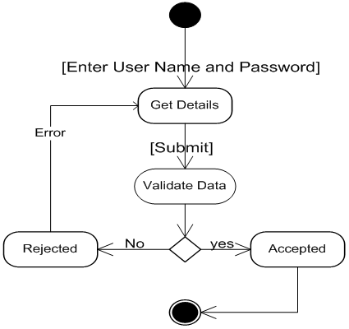

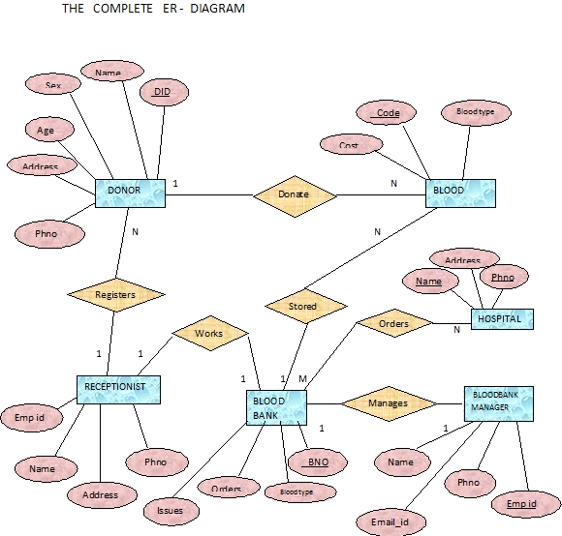

**10.2 Data Flow Diagram**

**10.2.1 Introduction of DFD**

A DFD, in simple words, is a hierarchical graphical model of a system that shows the different processing activities or functions that the system performs and the data interchange among these functions. In the DFD terminology, it is useful to consider each function as a process that consumes some input data and produces some output data.

The DFD (also known as the bubble chart) is a simple graphical formalism that can be used to represent a system in terms of the input data to the system, various processing carried out on these data, and the output data generated by the system) The main reason why the DFD technique is so popular is probably because of the fact that DFD is a very simple formalism- it is simple to understand and use. A DFD model uses a very limited number of primitive symbols to represent the functions performed by a system and the data flow among these functions. Starting with a set of high-level functions that a system performs, a DFD model hierarchically represents various sub functions. In fact, any hierarchical model is simple to understand. Human mind is such that it can easily understand any hierarchical model of a system-because in a hierarchical model, starting with a very simple and abstract model of a system; different details of the system can be slowly introduced through different hierarchies.

**10.2.2 Context Diagram**

A special data flow diagram(DFD) known as context diagram that represents an entire system as a single process and highlights the interfaces between the system and the outside entities.

**10.2.3 Need of DFD**

DFD aim’s to capture the transformation that takes place within a system to the input data so that eventually output is produced. It makes easier for user to understand the flow of data.

**10.2.4 Primitive Symbols Used for Constructing DFDs**

**10.2.4.1 Function Symbol**

A function symbol is represented as circle. This symbol is called a Process or a bubble. Bubbles are annotated with the names of corresponding functions.

**10.2.4.2**  **External Entity Symbol**

An external entity such as a manager, customer, etc. is represented by a rectangle. The external entities are essentially those physical entities external to the software system, which interact with the system by inputting data to the system or by consuming the data produced by the system. In addition to the human users, the external entity symbols can be used to represent external hardware and software such as another application software.

**External**

**Entity**

**10.2.4.3 Data Flow Symbol**

A directed arc or an arrow is used as a data flow symbol. A data flow symbol represents the data flow occurring between two processes, or between an external entity and a process, in the direction of the data flow arrow. Data flow symbols are usually annotated with the corresponding data names.

**10.2.4.4 Data Store Symbol**

A data store represents a logical file. It is represented using two parallel lines. A logical file can represent either a data store symbol which can represent either a data structure or a physical file on disk. Each data store is connected to a process by means of a data flow symbol. The direction of the data flow arrow shows whether data is being read from or written into a data store. An arrow flowing in or out of a data store implicitly represents the entire data of the data store and hence arrows connecting to a data store need not to be annotated with the name of the corresponding data items.

**10.2.5 DFD For Admin Login**

**A**fter entering to the home page of the website , admin can choose the ADMIN LOGIN option where they are asked to enter username & password , and if he/she is a valid user then admin login page will be displayed.

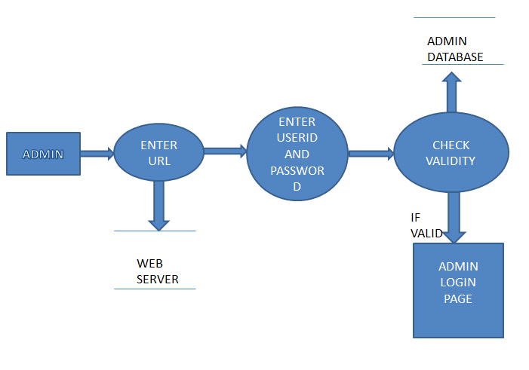

**10.2.6 DFD For User Login**

After entering to the home page of the website , student can choose the USER LOGIN option where they are asked to enter username & password , and if he/she is a valid user then a user login page will be displayed.

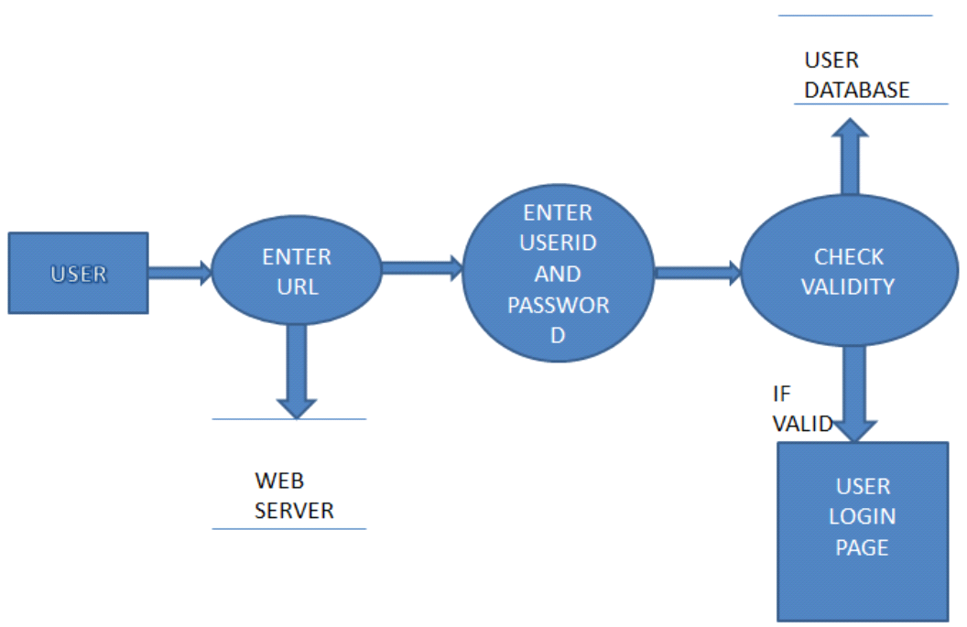

**11.2.7 DFD For Account Creation**

After the home page login there will be an option of CREATE AN ACCOUNT where after entering user detail ,if all the fields are filled then a request will be sent to the librarian who will approve him as a registered member of the website.

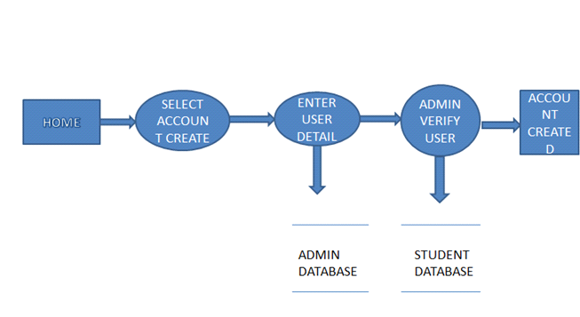

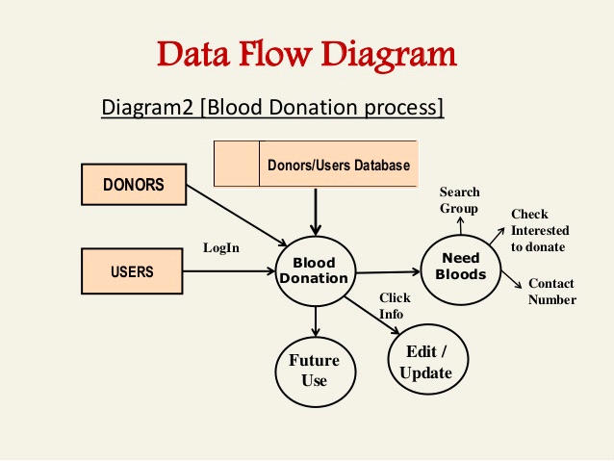

**11. Software Testing**

Testing is the process of executing then programs with the intention of finding out errors. During the process, the project is executed with set of test and the output of the website is evaluated to determine if the project is performing as expected. Testing makes a logical assumption that if all the parts of the module are correct then goal will be successfully achieved. Testing includes after the completion of the coding phase. The project was tested from the very beginning and also at each step by entering different type of data. In the testing phase some mistakes were found, which did not come to knowledge at the time of coding the project. Then changes were made in the project coding so that it may take all the relevant data and gives the required result. All the forms were tested one by one and made all the required changes.

Testing is vital to the success of the system. Testing makes a logical assumption that if all the parts of the system are correct, the goal will be successfully achieved. A small system error can conceivably explode into a much larger problem. Effective testing early in the process translates directly into long-term cost savings from a reduced number of errors. For the verification and validation of data various-nesting task are performed. Testing is itself capable of finding the syntactical mistakes in the system but user need to test the system for logical checking.

**11.1 Levels of Testing**

The aim of the testing process is to identify all the defects in the website. It is not practical to test the website with respect to each value that the input request data may assume. Testing provides a practical way of reducing defects in the website and increasing the user’s confidence in a developed system. Testing consists of subjecting the website to a set of test inputs and observing if the program behaves as expected. If the program fails to Testing behave as expected then conditions under which failure occurs are noted for later debugging and correction. The following things are associated with testing:

Failure is a manifestation of an error. But the mere presence of an error may not necessarily lead to a failure. A test case is the triplet [I, S, O] where I am data input to the system. S is the state of the state of the system at which the data is input, O is the expected output of the system A test suite is the set of all test cases with which a given software product is to be tested.

**11.2 Fuctional Testing**

Here the system is a black box whose behavior is determined by studying its inputs and related outputs. The key problem is to select the inputs that have a huge probability of being members of a set in may case; the selection of these test cases is based on the previous studies.

**11.3 Structural Testing**

A great deal can be learnt about the strength and the limitation of the application by examinee the manner in which the system breaks. This type of testing has two limitations.

It tests failure behavior of the system circumstances may arise through an unexpected combination of events where the node placed on the system exceeds the maximum anticipated load.

The structure of the each module was checked at every step. Some structures were firstly wrong, which came to notice at the time of the connectivity.

**11.4 Unit Testing**

In unit testing the entire individual functions and modules were tested independently. By following this strategy all the error in coding were identified and corrected. This method was applied in combination with the white and black box testing techniques to find the errors in each module.

Unit testing is normally considered an adjunct to the coding step. Unit test case design was started after source level code had been developed, reviewed, and verified for correct syntax. A review of design information provides guidance for establishing test cases that were likely to uncover errors in each of the categories discussed above. Each test case was coupled with a set of expected results.

**11.4.1 Testing Admin Login Form**

This form is used for log in of administrator of the system.In this we enter the username and password if both are correct administration page will open other wise if any of data is wrong it will get redirected back to the login page and again ask for username and password

**Test for User Login Module**

**Test for User login Form:**-This form is used for log in of user .In this we enter the, username and password if all these are correct User login page will open other wise if any of data is wrong it will get redirected back to the login page and again ask for username and password.

**Test for account creation:-** This form is used for new account creation when user does not fill the form completely it asks again to fill the whole form when he fill the form fully it gets redirected to page which show waiting for conformation message as his data will be only added by administrator after verification.

**12.5 Integrity Testing**

Integrity phases the entire module using the bottom-up approach and tested them. Integrity testing is a systematic technique for constructing the program structure while at the same time conducting tests to uncover errors associated with interfacing. The objective was to take unit tested modules and build a program structure that has been dictated by design.

The testing strategy has two different approaches namely the top-down approach in which the integration is carried out from the top-level module to the bottom and the bottom-up approach in which the integration is carried out from the low-level module to the top.

The modules were tested using the bottom-up approach by introducing stubs for the top-level functions. This test was used to identify the errors in the interfaces, the errors in passing the parameters between the functions and to correct them.

**There are two types of testing available**

**12.5.1.1 Black Box Testing**

In black box testing the structure of the program is not considered. Test cases are decided solely on the basis of the requirements or specifications of the program or module, and the consideration for selection of test classes. In this section, we will present some techniques for generating test cases for black-box testing. In black-box testing, the testing only knows the inputs that can be given to the system and what output the system can give. In other words the basis for deciding test case in functional testing is the requirement or specification of the system module. This form of testing is obvious functional or behavioral testing.

The most obvious functional testing procedure is exhaustive testing, which as we have stated, is empirical. One criterion for generating test causes is to strategy has little chance of resulting in a set of test causes that is close to optimal(i.e. that detects the maximum errors with minimum test cases). Hence we need some other criterion or rule for selecting test cases. There are no formal rules for designing test cases for functional testing. In fact there are no precise criteria for selecting test cases however, there have been found to be very successful in detecting errors. Here we mention some of these techniques.

**12.5.1.2 White Box Testing**

In the previous section we discussed testing, which is concerned with the function that the tested program is proposed to program and does not deal with the internal structure of the program responsible for actually implementing that function. Those black-box testing is concerned with functionality rather than implementation of the program. On the other hand, white-box testing is concerned with testing implementation of the program. The intent of this testing is not to exercise all the different input or output conditions(although that may be buy products) but to exercise the different programming structures and data structures used in the program. White-box testing is also called structure testing and we will use the two terms interchangeably to test the structures of a program, structural testing aims to achieve test cases that force the desired coverage of different structures various criteria have been proposed for this. Unlike the criteria for functional testing which are frequently imprecise, the criteria for structural testing are generally quite precise as they are based on program structures, which are formal and precise.

**13.Complete Snapshots**

**13.1 Home page** This is the home page or the main page of a Blood Donation Camp. This is the main page of a client side. This page define all about related to project. This page also includes the galary of the camps.

Blood Donor

Blood Recipient

Blood Collection

Camp

Stock details

Blood Donation Camp Project Reports

Blood Issued

**Figure 13.1:Home Page of life saver**

**13.2 Registration**

Registration page includes the information of the donor who want to register. Donor can register the account by clicking on new register. He/she can add the account for the further enquiry of the blood donation.

**Figure 13.2:Registration page of Life Saver**

**13.3 Request For Blood**

Request for blood page includes the information of the donor who want to register. Donor can register the account by clicking on new register. He/she can send requests for the further enquiry of the blood donation.

**Figure 13.3:Request for Blood page**

**13.4 Camps**

Camp page includes the information about camps, this camps organised the blood donation camp. Donor can register the account by clicking on new register.

Request for blood page includes the information of the donor who want to register. Donor can register the account by clicking on new register. He/she can send requests for the further enquiry of the blood donation.

**Figure 13.4:Camps of Blood group**

**13.5 Donor Login**

It is  login menu, I have set a default E-mail and password for it. This mail id and password are store in a binary file inside this project. For Password security I have replace the password's alpha numeric character to special symbol, Dollar ($) symbol.

If you will enter the correct mail id and password, It will allow you to move to next menu otherwise it will show you error message and ask you to invalid mail id and password.

Request for blood page includes the information of the donor who want to register. Donor can register the account by clicking on new register. He/she can send requests for the further enquiry of the blood donation.

**Figure 13.5:DONOR Log In**

**13.6 Search**

Search button is used for search the donations of blood for a different defferent blood groups.

Blood groups name

* A
* A+
* B
* B+
* AB+
* AB_
* O+
* O-

**Figure 13.6:Search for Blood**

**13.7 Contact**

In contact page any one who wants to need a blood or gaining a information about this system then he/she can contact with us.

Person will get the blood immediately he/she requested for the particular blood group he/she

Has requested.

**Figure 13.7:Contact Us**

**13.8 Donor Pannel**

This page is the the welcome page of the donor panel. In this page include all the module related to Donor like :

Change password

Update profile

Blood donated

View donation

View requested

Logout

**Figure 13.8:Welcome To Donor Pannel**

**13.9 Change Password**

Above snap short describe how the donor change our password .This is only used by a donor.

**Figure 13.9:Change Password**

**13.10 Update Profile**

Above snap short describe how the donor update our profile .This is only used by a donor.

**Figure 13.10:update Profile**

**13.11 Blood Donated**

Above snap short describe about donation from donor.This is only used by a donor.

Person will get the blood immediately he/she requested for the particular blood group he/she

has requested.

**Figure 13.11:Blood Donated**

**13.12 Admin Pannel**

This is the admin side of the project, shows all the admin page like addition , updation, deletion of the user, city,state,camps etc.

Person will get the blood immediately he/she requested for the particular blood group he/she

has requested.

**Figure 13.12:Admin Pannel**

**13.13 Add user**

Show the addition of user.

Person will get the blood immediately he/she requested for the particular blood group he/she

has requested.

**Figure 13.13:Admin Pannel**

**13.14 Update User**

Show the updation of user.

**Figure 13.14:Update User**

**13.15 Add City**

Show the addition of city.

Person will get the blood immediately he/she requested for the particular blood group he/she

has requested.

**Figure 13.15:Add City**

**13.16 Update City**

Show the updation of city.

Person will get the blood immediately he/she requested for the particular blood group he/she

has requested.

**Figure 13.16:Update City**

**13.17Add Camp**

Show the addition of camp.

Person will get the blood immediately he/she requested for the particular blood group he/she

has requested.

**Figure 13.17:Add Camp**

**13.18 Update Camp**

Show the updation of camp.

Person will get the blood immediately he/she requested for the particular blood group he/she

has requested.

**Figure 13.18:Update Camp**

**13.19 Add State**

Show the addition of state.

Person will get the blood immediately he/she requested for the particular blood group he/she

has requested.

**Figure 13.19:Add State**

**13.20 Update State**

Show the updation of state.

Person will get the blood immediately he/she requested for the particular blood group he/she

has requested.

**Figure 13.20:Update State**

**13.21 View Blood Group**

This snapshort shows all the blood group. This shows blood group name and id**.**

Person will get the blood immediately he/she requested for the particular blood group he/she

has requested.

**Figure 13.21:View Blood Group**

**14. Conclusion**

With the theoretical inclination of our syllabus it becomes very essential to take the atmost advantage of any opportunity of gaining practical experience that comes along. The building blocks of this Major Project ” **BLOOD DONATION CAMP**” was one of these opportunities. It gave us the requisite practical knowledge to supplement the already taught theoretical concepts thus making us more competent as a computer engineer. The project from a personal point of view also helped us in understanding the following aspects of project development:

* The planning that goes into implementing a project.
* The importance of proper planning and an organized methodology.
* The key element of team spirit and co-ordination in a successful project.

The project also provided us the opportunity of interacting with our teachers and to gain from their best experience

**15. Future Recommendation**

**Blood Donation Camp** is a software application to built such a way that it should suits for all type of blood banks in **future**. One important future scope is availability of location based blood bank details and extraction of location based donor’s detail, which is very helpful to the acceptant people. All the time the network facilities cannot be use. This time donor request does not reach in proper time, this can be avoid through adding some message sending procedure this will help to find proper blood donor in time. This will provide availability of blood in time.

**16. Bibliography**

1. https://www.php.net
2. https://www.google.com
3. [http://www.w3schools.com](http://www.w3schools.com/)
4. http://www.indianbloodgroup.com

.